**Advanced JavaScript**

**Author:** Apurva Sachin Kulkarni

**Date:** 26th August, 2025

**Introduction**

JavaScript is one of the mostwidely used programming languages in the world. While beginners often start with basics like variables, loops, and functions, advanced developers need to understand more powerful concepts that make JavaScript suitable for asynchronous programming, event-driven applications, and functional programming.

This document covers four of the most important advanced concepts:

1. Callback Functions
2. Promises
3. Async / Await
4. Closures

**1. Callback Functions:**

**What is a Callback?**

A callback function is a function passed into another function as an argument and executed later, usually after some task completes.

In JavaScript, functions are first-class citizens, meaning:

* They can be assigned to variables.
* Passed as arguments to other functions.
* Returned from other functions.

Callbacks are the foundation of asynchronous programming in JavaScript.

**Example –**

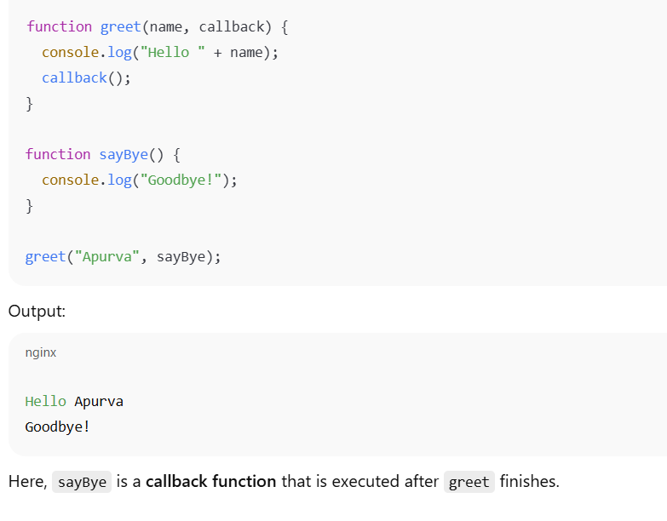

**Asynchronous Callback**

Callbacks are extremely useful for non-blocking code execution.

**Callback Hell**

When callbacks are nested deeply, code becomes hard to read and maintain. This pyramid-like structure is known as Callback Hell. It makes debugging and maintenance difficult.

**Real-World Use Cases of Callbacks**

* Reading a file in Node.js (fs.readFile)
* Handling button clicks in web apps
* API requests before Promises were introduced

**2. Promises:**

**What is a Promise?**

A Promise is a JavaScript object that represents the eventual completion (or failure) of an asynchronous operation.

It has three states:

1. **Pending** – initial state
2. **Fulfilled** – operation completed successfully
3. **Rejected** – operation failed

**Example –**

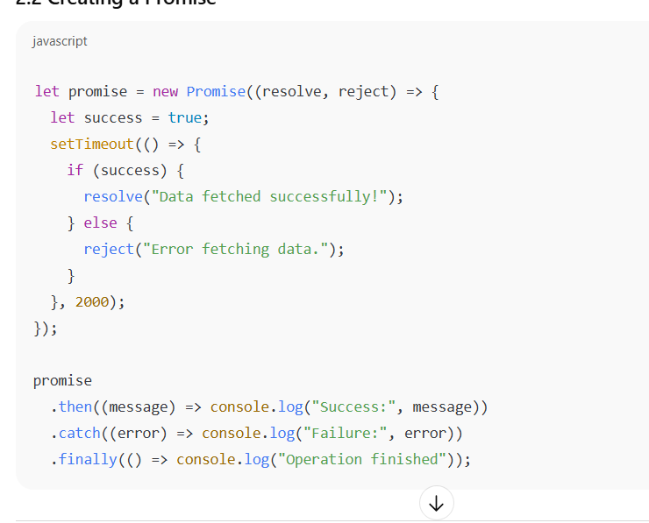

**Why Promises?**

* Avoid Callback Hell
* Provide cleaner syntax
* Easier error handling

**Promise Chaining** - Promises can be chained using .then()

**Real-World Use Cases of Promises**

* Fetch API (fetch("url").then(...).catch(...))
* Database queries in Node.js
* Animations and delays

**3. Async Functions and Await:**

**What is Async/Await?**

Introduced in ES2017, async/await allows writing asynchronous code in a synchronous-looking way.

* async → makes a function return a Promise
* await → pauses execution until the Promise resolves

**Example –**

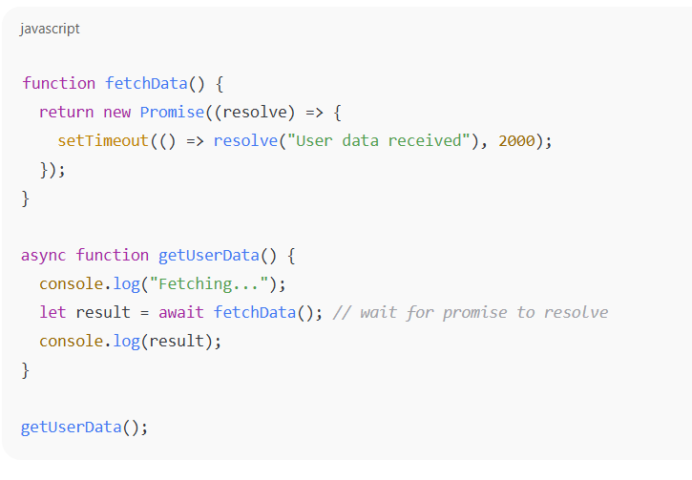

**Error handling with try catch –**

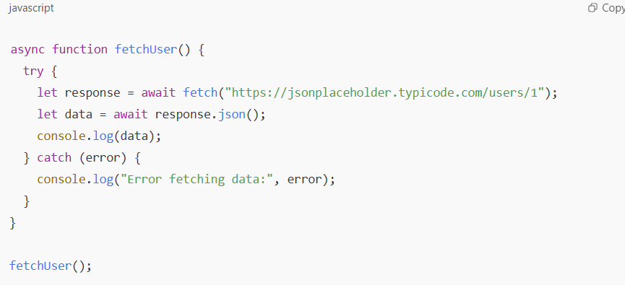

**Why Async/Await?**

* Improves readability
* Easier debugging
* Works perfectly with Promises

**Real-World Use Cases of Async/Await**

* API calls
* Database queries
* File operations in Node.js

**4. Closures:**

**What is a Closure?**

A closure is created when a function "remembers" its lexical scope, even when executed outside of it.

**Example –**

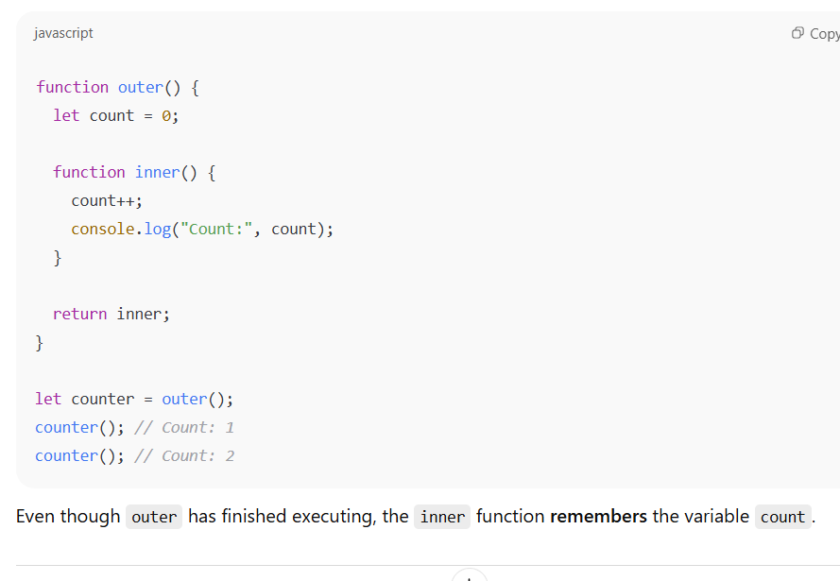

**Real-World Use Cases of Closures**

* Private variables in JavaScript
* Event handlers remembering state
* Functional programming patterns

**Table 1: Comparisons**

|  |  |  |  |  |
| --- | --- | --- | --- | --- |
| **Feature** | **Callback** | **Promise** | **Async/Await** | **Closure** |
| Primary Use | Async tasks | Async tasks | Async tasks with cleaner syntax | State management |
| Syntax | Function argument | .then() .catch() | async/await | Nested function |
| Readability | Low (Callback Hell) | Moderate | High | Moderate |
| Error Handling | Manual | .catch() | try...catch | N/A |
| Example Use | Event listener | API fetch | API fetch | Private variables |

**Conclusion**

Callbacks are the foundation of asynchronous programming but can lead to Callback Hell.Promises solve this problem by providing a cleaner, chainable API.Async/Await makes asynchronous code easier to read and debug.Closures enable data encapsulation and state persistence, essential in many JavaScript patterns.Together, these concepts form the backbone of modern JavaScript applications, making them more scalable, maintainable, and powerful.

***